Liffey Valley to City Centre Construction Update
December 2025

Table of Contents
Introduction....................................................................................................................... 1

Project Update ................................................................................................................... 1

Contact GMC..................................................................................................................... 2

Location Maps ................................................................................................................... 2

Compound 1: Fonthill Road ............................................................................................ 2

Compound 2: Coldcut Road ........................................................................................... 3

Compound FAQs................................................................................................................ 3

When will work take place?............................................................................................. 3

What are the hours of work? ........................................................................................... 3

What safety measures will be in place? ........................................................................... 3

How will dust and dirt on nearby roads be managed?....................................................... 4

What about noise and vibrations? ................................................................................... 4

How will access to the area be managed during works? ................................................... 4

How can I stay informed about the works?....................................................................... 4

Liffey Valley to City Centre Map........................................................................................... 4

Introduction

BusConnects is a city shaping project that will connect people and places through an enhanced sustainable transport system, together with improved cycling and pedestrian infrastructure across the Greater Dublin area.

BusConnects will deliver more frequent bus services across 12 new corridors across the city, which will include the construction of 230 kilometres of bus corridors and 200 kilometres of cycle lanes.

Project Update

Site works for the Liffey Valley to City Centre BusConnects Scheme are scheduled to commence in December 2025. The initial phase will involve setting up two site compounds. The first will be positioned along Fonthill Road, beside Tesco Extra, and will be used mainly for storage and parking. While some off-road works are planned in this
area, activities will be concentrated off-road to minimise disruption during the busy pre- Christmas period. The second compound will be located along Coldcut Road, on lands adjacent to the Eir Exchange building between Cloverhill Road and Ballyfermot Road, and will primarily serve as a material storage area, with a welfare unit, site office, and limited staff parking also provided. Please refer to the location maps below for further details.

Contact GMC

We encourage community feedback throughout the project, so please don’t hesitate to contact us. You can share your comments or questions by emailing infor@gmcirl.com or phoning (01) 8649800.

Location Maps

Compound 1: Fonthill Road

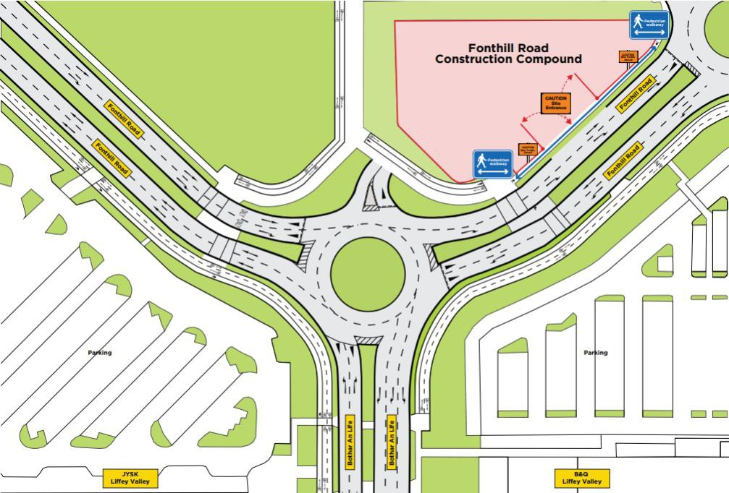
Compound 2: Coldcut Road

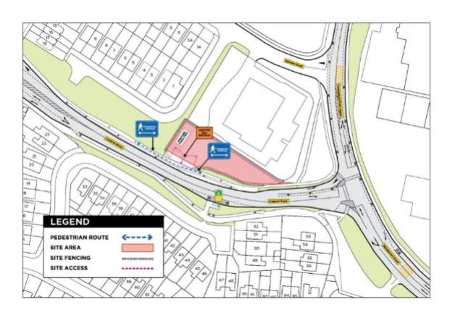

Compound FAQs

When will work take place?

The setup of the compound will begin in early December 2025. Works are expected to last approximately two weeks, with the compound remaining in use for the duration of the project.

What are the hours of work?

Works will generally take place Monday to Friday from 7 am to 7 pm. In local areas, residents will be notified well in advance of any activity outside these hours, which will be kept to a minimum wherever possible.

What safety measures will be in place?

All perimeters will be barricaded to ensure the area is safely secured during use. When not in use, site compounds will be locked, preventing unauthorised access. Regular site safety checks will be carried out throughout the project. Every effort will be made to keep residents informed of ongoing site activities, with a dedicated local liaison officer providing regular updates. Clear and abundant signage, along with maintenance notices, will be prominently displayed throughout the site to alert the public to any potential hazards associated with unauthorised access.
How will dust and dirt on nearby roads be managed?

Some dust may be generated during site set-up and daily use. To reduce this, a water bowser will be used for dust suppression as required, and road sweepers will operate along affected routes when needed. We are committed to keeping surrounding roads and public areas clean, safe, and well maintained throughout the project.

What about noise and vibrations?

Noise and vibration levels will be regularly monitored throughout construction. When necessary, noise mitigation measures, such as acoustic enclosures and vibration monitoring, will be implemented. Most activity within the compound will involve storage operations, helping to keep overall noise to a minimum.

How will access to the area be managed during works?

A comprehensive Traffic Management Plan (TMP) will be developed and implemented in agreement with the County Council and key stakeholders. The plan is designed to maintain safe and efficient access and egress, while minimising disruption to local traffic, pedestrians, and cyclists.

How can I stay informed about the works?

Updates and further information are available on our website: liffeyvalleyscheme.ie. Here you can also sign up to receive project updates by email. For direct queries, contact 1800 303 700. Or speak directly with our Public Liaison Officer, Samantha Keely on 087 332 4997 or samantha.keely@gmc.irl.com

Liffey Valley to City Centre Map

